

|  |  |  |  |  |  |  |  |  |
| --- | --- | --- | --- | --- | --- | --- | --- | --- |
|  | | | | | | | | |
|  | | ShopNest Store Power BI Capstone Project Report | | | | |  | |
|  |  | | | | | | |  |
|  | | | |  |  | | | |
|  | | | | DHIVYALAKSHMI K B |  | | | |
|  | | | | 16/12/2024—DAP-202407-1— |  | | | |
|  | | |  | | |  | | |

|  |  |  |  |  |  |  |  |  |
| --- | --- | --- | --- | --- | --- | --- | --- | --- |
|  |  | | |  |  | | |  |
|  | Agenda | | | | | | |  |
|  |  | | |  |  | | |  |
|  |  | |  | | |  | |  |
|  |  |  | In this Capstone project, an Interactive and Informative Dashboard is created to analyse various trends of ShopNest Store’s sales using Power BI visualization tool. | | |  |  |  |
|  | | | | |
|  |  |  |  |
|  |  |

|  |  |  |  |  |  |  |  |
| --- | --- | --- | --- | --- | --- | --- | --- |
| Decorative | |  |  |  |  | | |
|  | | INTRODUCTION | | | |  | |
|  | |  |  |  |  | | |
|  | ShopNest StoreShopNest store stands as the leading department store in the e-commerce marketplaces in Portugal. It allows merchants to showcase and sell their products with the added convenience of direct shipment to consumers.  Raw Data Set There are 9 datasets as follows :   1. Customers_dataset 2. Geolocation_dataset 3. Order_items_dataset 4. Order_payments_dataset 5. Order_reviews_dataset 6. Orders_dataset 7. Products_dataset 8. Sellers-dataset 9. Product_categories | | | | | |  |

##### Dashboard Contents

The dashboard contains 5 separate reports to provide detailed analysis in each level as follows :

1. Product level Analysis
2. Order level Analysis
3. State level Analysis
4. Yearly & Quarterly Order Analysis
5. Yearly & Quarterly Revenue Analysis

##### Dashboard Walkthorugh

1. Home Page

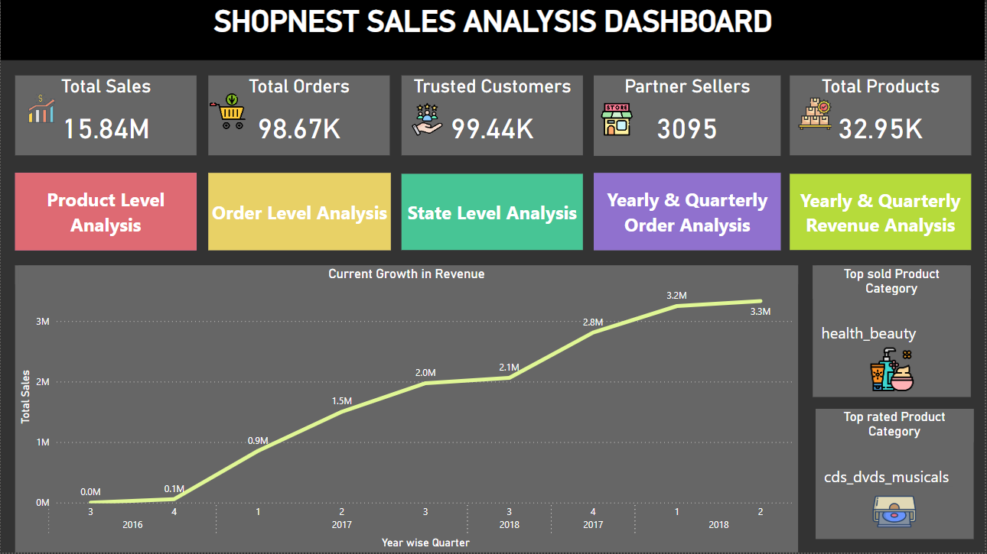

The homepage contains quick insights on

1. Total Sales
2. Total Orders
3. Trusted consumers gained
4. Sellers in partnership with
5. Current Total products

It also showcases the Revenue trend across 2016, 2017 and 2018. Currently we see revenue of 3.3 Million

It highlights the top sold & top rated Product category

Then, it contains buttons to navigate to various dashboards which contains detailed analysis at each level such as :

1. Product level Analysis
2. Order level Analysis
3. State level Analysis
4. Yearly & Quarterly Order Analysis
5. Yearly & Quarterly Revenue Analysis

* Product level Analysis Page

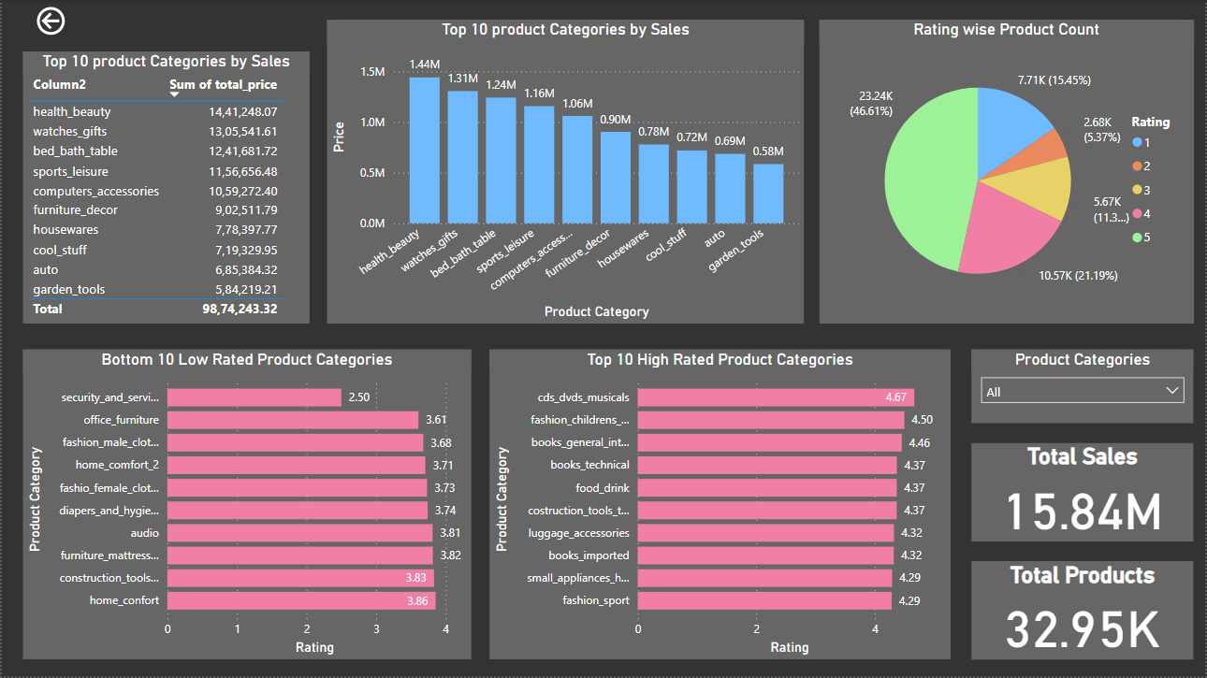

This page contains detailed report on

1. Top 10 product categories by sales
2. Top 10 High rated Product Categories
3. Bottom 10 Low rated Product Categories
4. Rating wise Count of Products
5. Total Sales & total Products in Sock

Insights

* Health_beauty is the top most sold product category
* Majority of the Products are rated between 4.1 - 5.0
* Security_and_services is the lowest rated product category
* Cds_dvds_musicals is the highest rated product category
* Order level Analysis Page

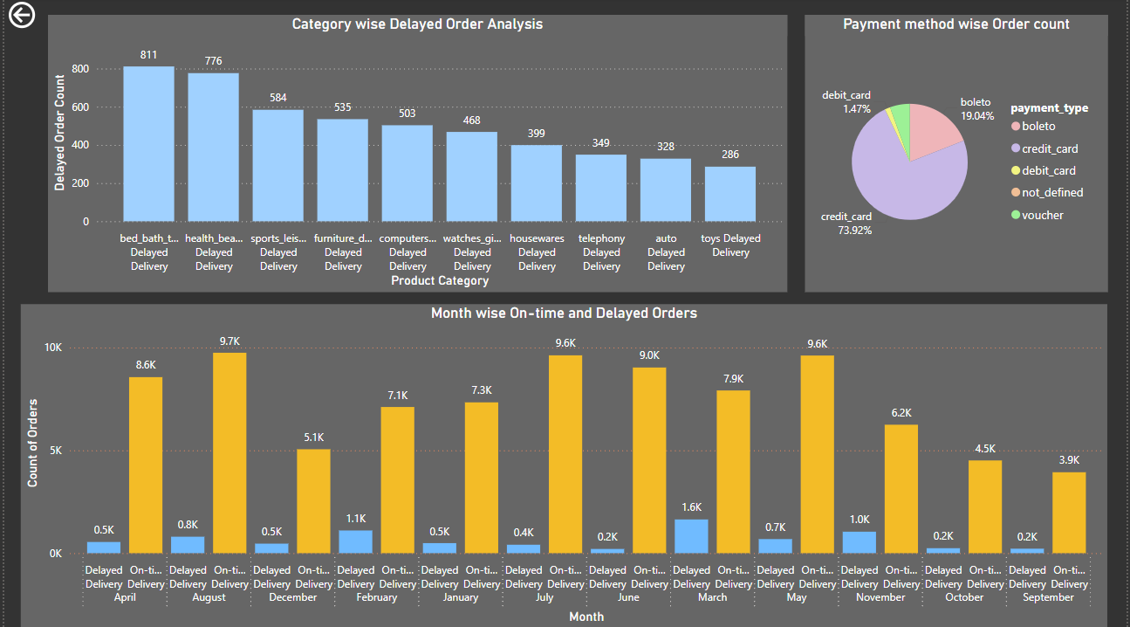

This page contains detailed report on

1. Product Category wise Delayed Order count
2. Payment method wise Order count
3. Month wise On-time and Delayed Orders

Insights

* Month of August has the highest orders which are delivered On-time
* Month of March has the highest orders with delayed delivery
* Bed_bath_table product category has the highest orders with delayed delivery
* Credit Card is the mostly and widely used payment method
* State level Analysis Page

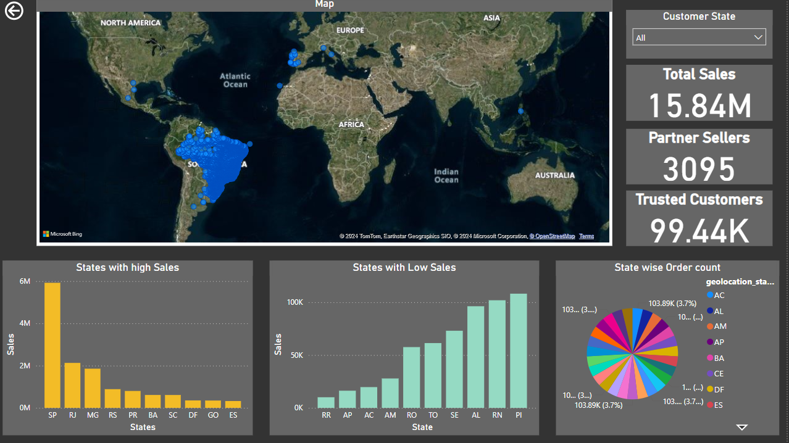

This page contains detailed report on

1. States offering high sales
2. States offering low sales
3. State wise order count
4. Total sales allover
5. Total Sellers available
6. Total Consumers gained
7. World map for easy navigation of States

Insights

* Sao Pablo contributes to high sales
* Boa Vista contributes to low sales
* Yearly & Quarterly Order Analysis

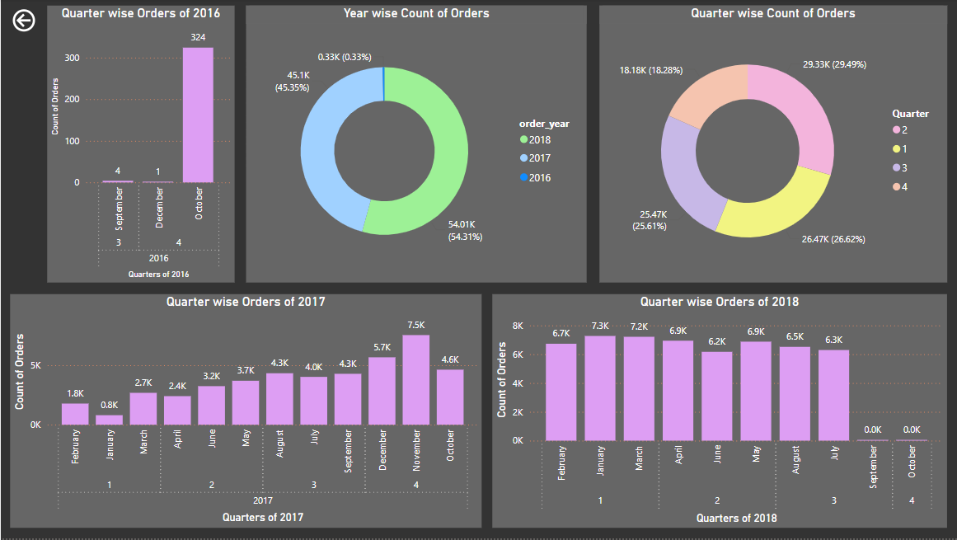

This page contains detailed report on

1. Quarter wise Orders of 2016, 2017, 2018
2. Year wise count of orders in total
3. Quarter wise count of orders in total

Insights

* In the year 2018, the Orders have significantly increased
* In 3 years, Quarter 2 has the maximum no. of Orders with 29.49%
* Yearly & Quarterly Revenue Analysis

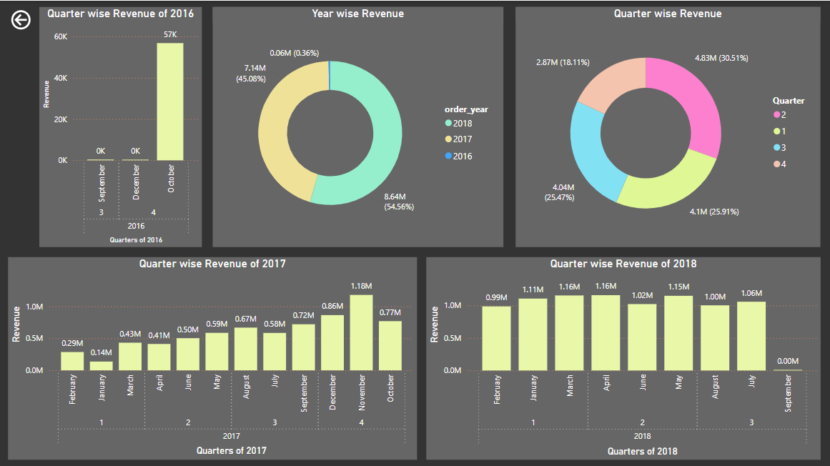

This page contains detailed report on

1. Quarter wise Revenue of 2016, 2017, 2018
2. Year wise revenue in total
3. Quarter wise revenue in total

Insights

* In 3 years, Quarter 2 has the maximum no. of Orders and hence has the maximum revenue generated upto 4.83 Million
* In 2017, the growth from minimum level is seen
* In 2018, there is an consistent revenue generated

##### Questions

1. Question Statement : Identify and visually represent the top 10 product categories by total sales.

Visualization : Top Categories by Total Price

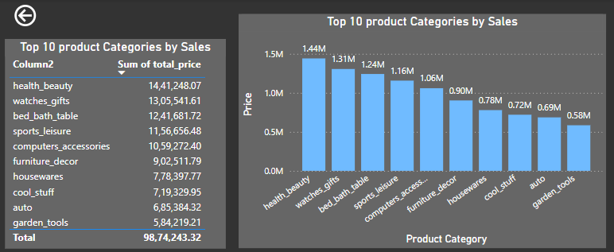

Explanation : health_beauty is the top most product category with total sales of $14,41,248.07

1. Question Statement : Determine the number of delayed orders in each category. An order is considered delayed if the actual delivery date is later than the estimated delivery date.

Visualization : Delayed Orders Analysis

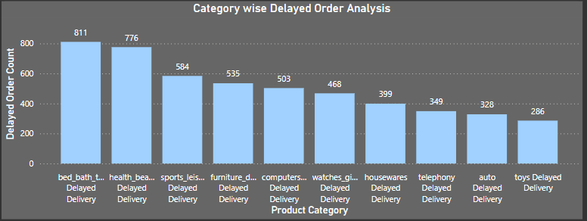

Explanation : Bed_bath_table product category has the highest orders with delayed delivery. It means the orders containing products of this particular product category is delivered late.

1. Question Statement : Create a dynamic visual that compares the number of delayed orders to the number of orders received earlier for each month. Utilize the drillthrough cross-report feature to provide a detailed analysis of late and on-time deliveries.

Visualization : Monthly Comparison of Delayed and On-Time Orders  
  
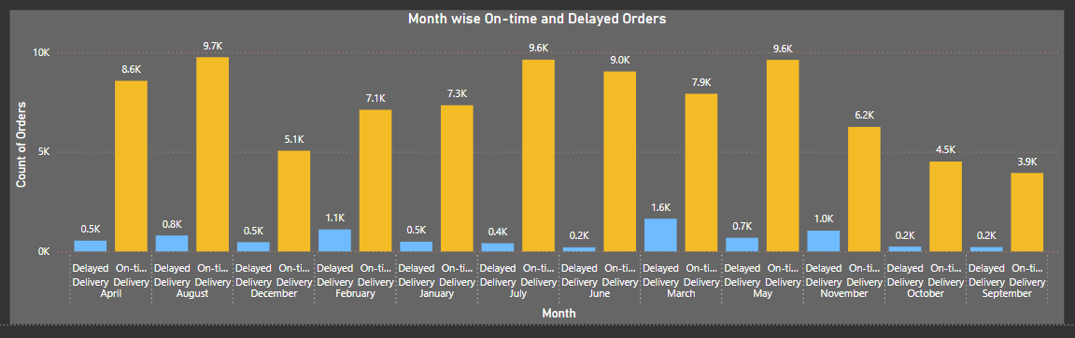

Explanation : Month of August has the highest no.of orders which are delivered On-time and Month of March has more no.of orders with delayed delivery  
  
Month of July looks more consistent with

No.of Delayed Orders : 0.4k and no.of On-time orders : 9.6k

1. Question Statement : Analyze the most frequently used payment methods by customers using a visually appealing representation, such as a pie chart or other suitable visuals.

Visualization : Payment Method Analysis

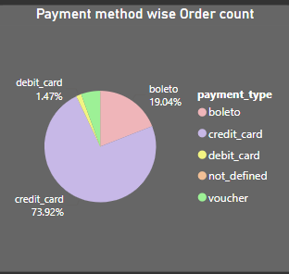

Explanation : Credit Card is the mostly and widely used payment method

1. Question Statement : Determine the top 10 highest-rated products and the bottom 10 lowest-rated products using a bar or column chart.

Visualization : Product Rating Analysis

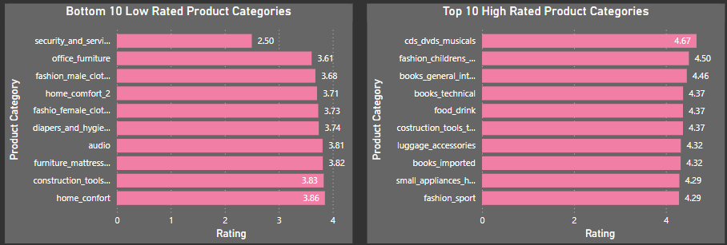

Explanation : Security_and_services is the lowest rated product category with average rating of 2.50 and Cds_dvds_musicals is the highest rated product category with average rating of 4.67

1. Question Statement : Identify and visually represent states with high and low sales, providing a clear understanding of regional sales performance.

Visualization : State-wise Sales Analysis

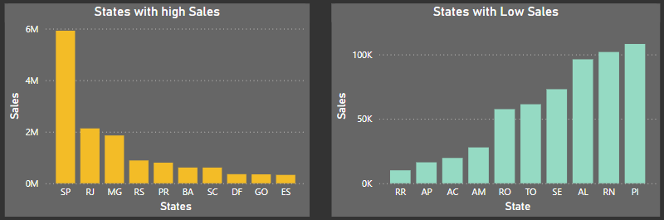

Explanation : State Sao Pablo contributes to high sales and State Boa Vista contributes to low sales

1. Question Statement : Investigate and visualize any seasonal patterns(Quarterly) or trends in sales data over the course of the year.

Visualization : Seasonal Sales Patterns

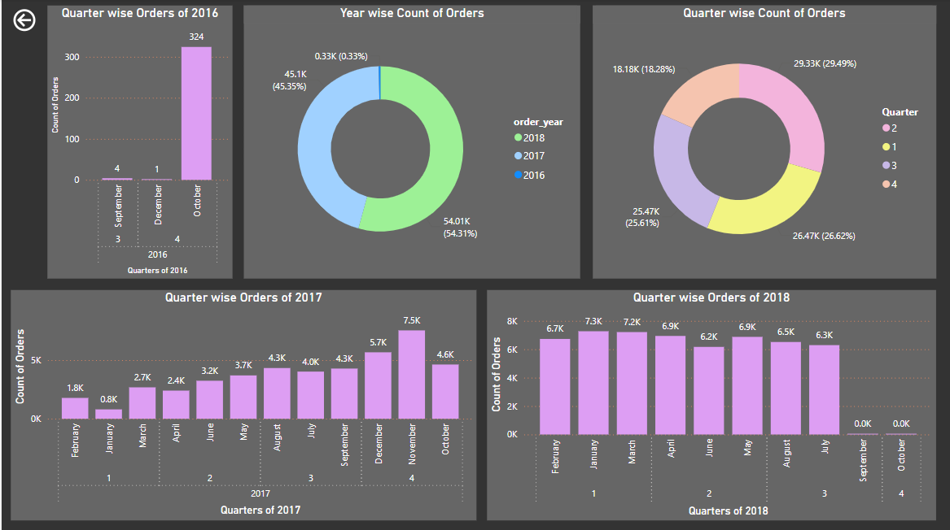Explanation :

In the year 2018, the Orders have significantly increased and In 3 years, Quarter 2 has the maximum no. of Orders with 29.49%  
Quarter 2 consists of months : April, May June which marks holiday season and thus increase in Sales is seen

1. Question Statement : Determine the total revenue generated by ShopNest Store and analyze how it changes over time(Yearly). Represent this information through suitable visuals to highlight trends and patterns.

Visualization : Revenue Analysis

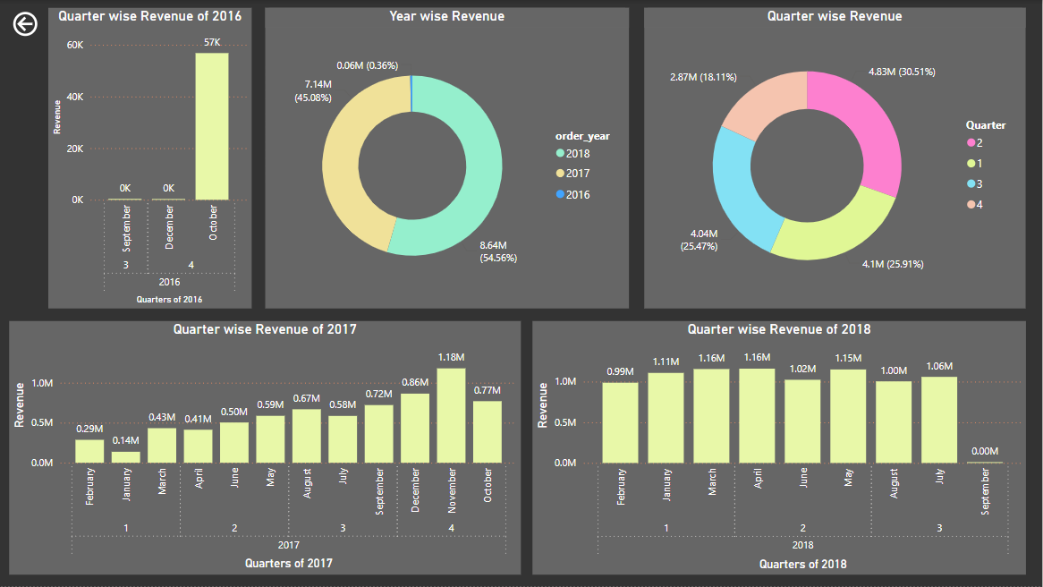

Explanation : In 3 years, Quarter 2 has the maximum no. of Orders and hence has the maximum revenue generated upto 4.83 Million

* In 2017, the growth from minimum level is seen from Qtr 1 towards Qtr 4
* In 2018, there is an consistent revenue generated

***The End***